
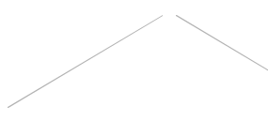
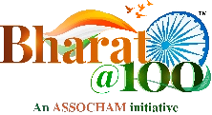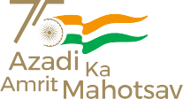
2nd India International Conference
MONEY LAUNDERING AND COLLECTIVE RESPONSE
Emerging Trends, Prevention, Detection and Investigation

New Delhi I Saturday, 12 November 2022 l 10:00 AM – 01:30 PM

REGISTRATION FORM

I/ we would like to attend/nominate the following:

 | Delegate 1 | Delegate 2 | Delegate 3
Name
Designation
Name of Organisation
GST No. of Organisation
Address
Tel #
Mobile #
Email

Registration Fee (Per Delegate) | ₹ 2,000/- + GST (18%) = ₹ 2,360/-
Claim the following entitlement to special benefits:
- Certificate of participation to all registered delegates
- 10% discount on nomination of 2 or more delegates from same organization/ for ASSOCHAM Members

METHOD OF PAYMENT | PAYMENT DETAILS
DD/Cheque in favour of ASSOCHAM payable at New Delhi
For NEFT/Online payment details: HDFC Bank Limited, 4/48, Malcha Marg Shopping Complex Chanakyapuri, New Delhi -110021 Saving Account No. 05031110000062 IFSC CODE: HDFC0004711
- Fee once paid is non – refundable, although change of nomination is allowed.
- The registration fee includes lunch, refreshments.
- Prior Registration is essential. Please fax/courier/email the registration form at the earliest.

Name & Designation of nominating authority (Signature)

Kindly send your ﬁlled-in registration form to:

Mr. Vikash Vardhman, Email: vikash.vardhman@assocham.com Mob: +91 90277 88277
Ms. Ritima Singh, Email: ritima.singh@assocham.com Mob: +91 93546 25618

THE ASSOCIATED CHAMBERS OF COMMERCE AND INDUSTRY OF INDIA
4th Floor, YMCA Cultural Centre and Library Building, 01, Jai Singh Road, New Delhi – 110001

